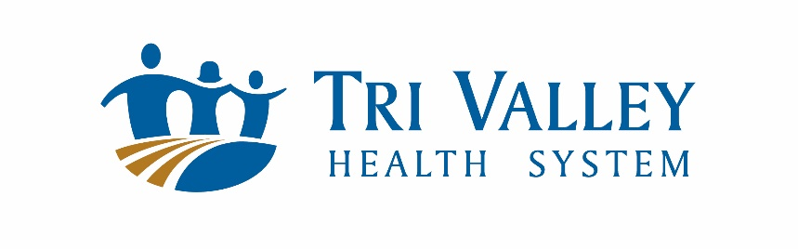
Nursing Tuition Assistance Application
Return the application and required documents to Tri Valley Health System Attention: Human Resources PO Box 488, Cambridge, NE 69022 or email to hr@trivalleyhealth.com. Application deadline is May 1.
Applicants will be scheduled for an interview. Approved applicants will be required to complete the tuition assistance agreement and a Tri Valley Health System employment application.

LAST NAME_________________________FIRST NAME______________________________

ADDRESS__________________________CITY_____________________________________

STATE_____________________________ZIP CODE_________________________________

PHONE____________________________CELL PHONE______________________________

EMAIL_______________________________________________________________________

CURRENT TVHS EMPLOYEE: YES □ NO □

CURRENT CERTIFIED NURSING ASSISTANT: YES □ NO □

HIGH SCHOOL_________________________YEAR GRADUATED__________

COLLEGE YEARS COMPLETED (Circle) 1 YEAR 2 YEARS 3 YEARS

THE FOLLOWING DOCUMENTATION MUST BE ATTACHED.
INCOMPLETE APPLICATIONS WILL NOT BE PROCESSED.

- RESUME 󠆰󠆰

- HIGH SCHOOL TRANSCRIPTS □

- COLLEGE TRANSCRIPTS □

- RECOMMENDATION FROM TWO INSTRUCTORS 󠆰 󠆰󠆰

- WHY I WANT TO BE A NURSE – 500 WORD ESSAY 󠆰󠆰

- PROOF OF APPLICATION TO NURSING SCHOOL (ASSISTANCE CONTINGENT UPON ACCEPTANCE, MUST SUBMIT ACCEPTANCE LETTER BEFORE ISSUANCE.)

_______________________________________ ______________________________
NAME DATE

