Counseling Services
Ambience Counseling 345-4067
Christian Counseling Services 345-4880
Cora Berry 345-1429
Growth & Enrichment Counseling 345-2932
Heartland Counseling
McCook 345-2770
Imperial 882-4203
North Platte 534-6029
Lexington 324-6754
Unified Therapy Clinic 345-4884

Abuse/Assault
Abuse/Neglect Hotline (All Ages) 800-652-1999
McCook Domestic Abuse/Sexual Assault Services
Office 345-1612
Crisis Line 345-5534
Prevent Child Abuse Nebraska 402-476-7226
Nebraska Family Help Line 888-866-8660

Aging
AARP 866-389-5651
Assistive Technology Project 888-806-6287
Health and Human Services See HHS Section
Nebr. West Central Agency on Aging 800-662-2961
Senior Citizen Centers
Arapahoe 962-5340 Eustis 468-3471
Beaver City 268-2501 McCook 345-1760
Dundy County 423-5454 Curtis 367-4173
Hayes Center 286-3233
Stratton 276-2661
Cambridge 697-4889
YMCA 345-6228

Community Service Groups
Contact local city office

AIDS
AIDS Hotline 800-782-2437
National Hepatitis Hotline 800-435-7443
National Sexually Trans. Diseases Hotline 800-227-8922

Alcohol/Drugs
Alcohol & Drug Abuse 24 hr Hotline 877-479-9777
Alcoholics Anonymous, Ala-teen, & Al Anon Time/Place
in Gazette (Community Calendar)
Boys & Girls Town 800-448-3000
Heartland Counseling 345-2770
Lifeline Recovery Services 344-8356
M.A.D.D. (Mothers against Drunk Drivers) 402-434-5330
National Institute of Drug Abuse 800-662-4357
S.A.D.D. (Students against Drinking and Drugs)
877-723-3462

Children/Youth
ABC Pregnancy Help Center 350-0126
CASA (Court Appointed Special Advocate) 340-6832
Early Development Network 345-7597
Family Resource Center 345-2609
Foster Care Program 800-772-7368
Girl Scouts 402-558-8189
Boy Scouts 382-3717
Juvenile Pretrial Diversion Program (see Co Attorney)
Child Passenger Inspection Station 344-2650
National Runaway Safe line 800-786-2929
Nebraska Family Helpline 888-866-8660
Planning Region Team 15 345-7597
Region II Human Services 345-2770
(Youth Care Coordinator)
Team Mates Mentoring Program 344-4532
UNL Ext. 4-H Youth Program 345-3390
YMCA 345-6228

City Offices
Arapahoe 962-7445 Hayes Center 286-3411
Bartley 692-3222 Indianola 345-2413
Beaver City 268-2145 Lebanon 375-4288
Benkelman 423-2540 Maywood 362-4299
Cambridge 697-3711 McCook 345-2022
Culbertson 278-2123 Palisade 285-3320
Curtis 367-4122 Trenton 364-5488
Eustis 486-3661 Wauneta 394-5390
Imperial 882-4368

Clothing

Community Action Partnership Mid-Nebraska 345-1187
Family Resource Center 345-2609
Sharing Place/McCook Christian Church 345-1516
Helping Hand Thrift Store 202 West 1st
Bargain Bazaar 215 West C
Goodwill Store Westview Plaza

Food
Commodity Foods 345-1187
Feeding HIS Flock (Thursday night) 345-2445
Home Delivered Meals 345-1760
Pantries
McCook 345-4844
Hitchcock County (Culbertson) 278-2123
Arapahoe 962-7296
Cambridge 697-3756
Oxford 824-3652
Western Frontier Country (Curtis) 367-8781
Dundy County (Benkelman) 423-2393
Chase County (Imperial) 882-5136
WIC-North Platte (West) 800-395-7336
WIC-Kearney (East) 877-803-1712

Employment
NE Workforce Development 345-8470
Vocational Rehab Services 535-8100
Goodwill 362-7030
Proteus Inc 532-4699

County Attorney
Chase 882-7515
Dundy 423-5225
Frontier 367-4141
Furnas 268-4135
Hayes 286-3486
Hitchcock 334-5616
Red Willow 345-7905

Housing (contact local city offices)
McCook Housing Agency 345-3605
USDA Rural Development 534-2360
West Central NE Dev. Dist. (Ogallala) 284-6077

Health and Disabled
ABC Pregnancy Help Center 350-0126
American Cancer Society 345-6274 or 800-642-8116
Community Health Care and Hospice 344-8356
Early Intervention Services 345-7597
Every Woman Matters (Ext. 134) 877-209-3723
Goodwill 362-7030
“Heartland” Day Rehab/Community Support 345-2770
Hospice 344-8356
Hotline for Disabilities 800-742-7594
League of Human Dignity 532-4911
Nebraska Children’s Home Society 534-3250
NE Comm for Deaf & Hard of Hearing 800-545-6244
NE Assistive Technology 877-713-4002
Patient Assistance Program 345-2609
People’s Family Health 345-3626

Red Willow County Health Dept. 345-1790
Respite Across the Lifespan 345-4990
Shriners Hospital 800-237-5055
SOAR 865-5675
Southwest Area Training Services (SWATS) 345-1530
Southwest Nebraska Public Health Dept. 345-4223

Law Enforcement (Non-Emergency )
McCook Police Department 345-3450
McCook Probation Office District 11 345-4070
Nebraska State Patrol 535-8047

County Sheriff Office
Chase 882-4748 Hayes 286-3364
Dundy 423-2393 Hitchcock 334-5444
Frontier 367-4411 Furnas 268-2245
Red Willow 345-1850

Other
McCook Humane Society 345-2372
Homeless – The Connection, North Platte 532-5050
Social Security, N. Platte 833-329-5527
UNL Extension Offices
Chase 882-4731 Hayes 286-3312
Dundy 423-2021 Hitchcock 334-5666
Frontier 367-4424 Furnas 268-3105
Red Willow 345-3390 Benkelman 423-2021

Support Groups
Diabetic (McCook Hospital) 344-8539
Time to Heal (Cancer) 334-8221
Grief Support 344-8221
Planning Region Team 15 (kids disabilities) 345-2595

Emergency Services
Community Action Partnership Mid-Nebraska 345-1187
Catholic Social Services (Imperial) 882-3065
Poison Control Center 800-222-1222
Salvation Army 345-1187
Suicide Prevention Lifeline 800-273-8255

Legal
Child Support Enforcement 877-631-9973
Legal Aid of Nebraska 877-250-2016

Transportation
Cambridge Handibus 697-4422
Hitch –n- Hay 276-2182
McCook Handibus 345-6098
Prince of the Road 888-452-3194
Chase County Transit. 882-5130
Medicaid ( Call Your Medicaid Provider}

Schools/Education
Arapahoe-Holbrook 962-5458
Cambridge 697-3322
Chase County
High School 882-4304
Elementary 882-4228
Dundy County-Stratton
High School 423-2738
Benkelman Elementary 423-2216
Haigler Elementary 297-3275
Stratton Elementary 276-2281
Eustis Farnam 486-3221
Hayes Center 286-5601
Hitchcock County Unified
Elementary (Culberson) 278-2131
Jr. /Sr. High (Trenton) 334-5575
Medicine Valley-Curtis
High School 367-4106
Elementary 367-4210
Maywood 362-4223
McCook Public Schools 344-4400
St. Patrick’s 345-4546
Southwest School
SW Elem. - Indianola 364-2613
SW Jr/Sr High - Bartley 692-3223
Wauneta-Palisade
Wauneta 394-5427
Palisade 285-3219
Adult Education / GED 345-8142 or 877-327-6433
English as a Second Language (ESL) 345-8142
ESU #11 995-6585
ESU# 15 Main Office Trenton 800 -322-5160
ESU#15 Special Education 345-7341
ESU#15 Alternative Education 345-7341
ESU #15 Migrant Education 345-7341
Head Start Frontier County 345-5846
Furnas County 697-3578 Red Willow County 345-2246
McCook Community College 345-8100 or 800-658-4348
Nebraska College of Technical Agriculture 367-4124
or 800-328-7847

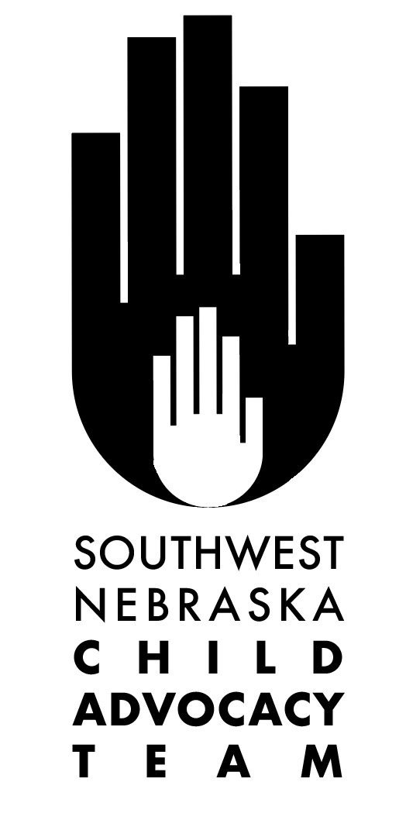

Southwest NE Resource
Directory

Resource Hotline-211
Police, Fire, Rescue, Sheriff-911

ALL NUMBERS ARE IN THE 308 AREA
CODE UNLESS OTHERWISE NOTED

Health and Human Service

Adult & Child Abuse Hotline 800-652-1999
McCook 800-778-1612
Economic Assistance 800-383-4278
Medicaid 855-632-7633

Medical Clinics
Curtis Clinic 367-4162
Heartland Family Medicine (Oxford) 824-3288
Chase County Clinic-Imperial 882-7299
McCook Clinic 344-4110
Quality Health Care – Benkelman 423-2151
Quality Urgent Care - McCook 345-7036
Stratton Clinic 276-2411
Trenton Regional Medical Clinic 334-5155
Tri Valley Health Systems Clinic
Arapahoe Clinic 962-8495
Cambridge Clinic 697-3317
Indianola Clinic 364-9290
Wauneta Family Practice Clinic 394-5593

Hospitals
Tri Valley Health Systems (Cambridge) 697-3329
Chase County Hospital-Imperial 882-7111
McCook Community Hospital 344-2650
Dundy County Hospital 423-2204

Medicaid Insurance Providers

Total Care 844-385-2192
United Health Care 800-641-1902
Well Care 855-599-3811

This Directory is provided by the Southwest Nebraska Child Advocacy Team.

The Southwest Nebraska Child Advocacy Team is a networking/interagency group that has been meeting monthly for more than 40 years. The group is open to anyone interested in the well being of children and families in our area.

The Southwest Nebraska Child Advocacy Team
is committed to addressing the unmet basic needs of children and families in our area by networking, collaborating and resource development. In addition to providing this Resource Directory, the group has been the catalyst for a number of projects/programs. These include: Head Start, MPS School Breakfast Program, Alternative Education (LIFT), ESL classes, Family Resource Center, Team Mates, parenting workshops, local Child Abuse Prevention/Awareness activities and many others.

To get more information about the Southwest Nebraska Child Advocacy Team please contact Kathy Haas at 345-2609.

2020 update

